29 July 2022

|  |
| --- |
|  |

|  |  |
| --- | --- |
|  | **ASSIGNMENT TOP SHEET**  **Higher National Diploma in Information Technology**  **Sri Lanka Institute of Information Technology** |

|  |  |  |  |
| --- | --- | --- | --- |
| Student Registration Number | Student Name | | |
| IT21714948 | M.A.M Bilal | | |
| Lab Group | PC number | | |
| N/A | N/A | | |
|  |  | | |
| Module Title: WEB APPLICATION DEVELOPMENT | | | Module Code: IT1201 |
| Lecturer in charge: Mrs. Gayana Fernando | | | |
| Assignment Title: Project Proposal | | | |
| Due Date:  29 July 2022 | | Date Submitted:29 July 2022 | |
| Please Tick here if you have used a proof-reader for this assessment: | | | |
| Turnitin Paper ID* | | | |

*Not required if not submitting via Turnitin

SLIIT Academy Logo Final Colour

|  |  |
| --- | --- |
| **Declaration** | |
| I declare that work presented in the assignment submitted to the Sri Lanka Institute of Information Technology is a record of an original work done by myself*.* This assessment is submitted in the partial fulfilment of the requirement for the award of the degree of Bachelor of Science in Information Technology. The results embodied in this report have not been submitted to any other University or Institution for the award of any degree or diploma. Information derived from the published or unpublished work of others has been acknowledged in the text and a list of references is given. | |
| *Name(s) and Signature(s):*  *M.A.M Bilal* | *Date:29 / 7 /2022* |

**Extension Deadline**

Lecturer in charge agrees that the assignment may be submitted ……………. days after the deadline and should be marked without penalty.

Lecturer in charge confirmation: ………………………………………………………………………………..

**Introduction and Description of the Project**

Our project is going to be the creation of a website for Lanka Trading Enterprise. This Enterprise is a Paint and Hardware store that sells paints and other hardware accessories in a variety of ranges.

The Primary focus will be marketing paints, updating information about upcoming paints on specific Paint companies and provide customers with access to purchase our product in Sri Lankan currency. We are looking to have the site up and running, without errors and browser compatibility issues, by the month of December.

The consumer has to register themselves. Once the consumer has registered himself/herself, he or she is able to view the products. Users can carry out a search to access the details for a paints and hardware. If it is paint, they are able to pick a color that they are satisfied with. Paints are available in specific ranges to meet the needs of the customers. Consumers can check new offers provided to them.

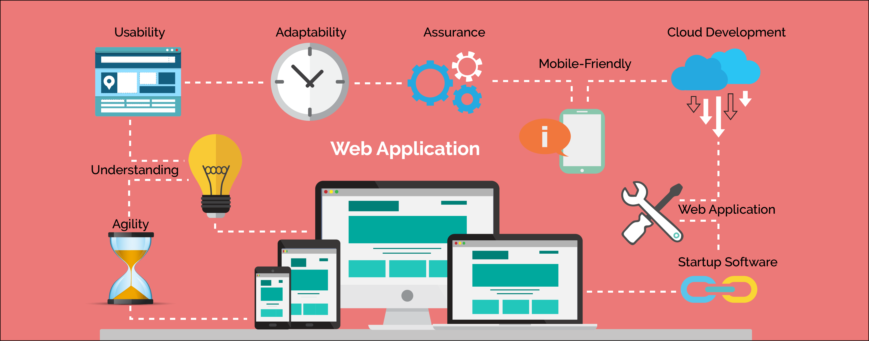

* 1. **Problem Specification**

Our Stock details are all available in the stores so that consumers will have to come to the store even to look out the details of paints. Product details are stored in books and all the updates regarding the product are done manually. If it is a paint, the consumer will have to wait for some time till the store finish in color mixing. Purchase is carried out using receipts.

* 1. **Solution Outline**

We came up with a solution to above called problems by developing a website that has a database link. This will allow us to store the details of our consumers, products. This will allow us to save a lot of energy and time.

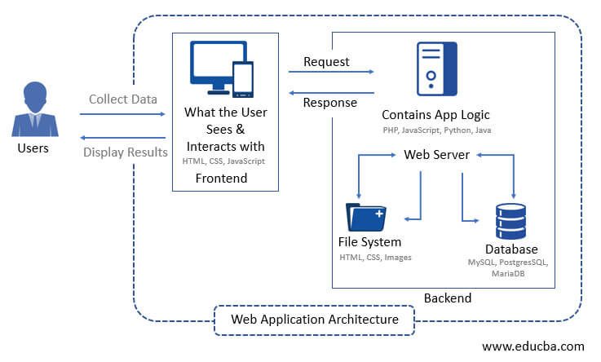

* 1. **Key Benefits**
* Instalment payment: - Consumers can pay through online transfer else pay on delivery.
* Time saves: - Consumers will not have to wait till the Color mixing is done or any other transaction to be done. Also, consumers can view details of product without visiting the store.
* More secure: - Sensitive information of employees will be protected.
* Productive Stock Handling: - Stock data can be effectively refreshed through back-end users, consequently giving up to date data.

**2. Details of System Functions**

1. **Name:** Sign-In  
   **Description:** Register a new user on the system by giving the system the following details. He or she can log in to the system using the Sign-In option.

* Name
* Mail address or Phone Number
* Password
* Address
* Privacy policy agreementIf user is unregistered, he or she cannot buy or add to cart (It will prompt to sign-in page) but unregistered users will be able to view the products.

1. **Name:** Account  
   **Description:** Registered Users will be able to see product details he or she bought in past. Also, the users will be able to see current products which is in purchasing stage or also view the products added to cart.
2. **Name:** Add to Cart  
   **Description:** Once the user selects a product, he or she will be able to add the product to the cart by clicking ‘Add to Cart’ button. So that the User will be able to purchase it later.
3. **Name:** View Cart  
   **Description:** User will be able to see the products added in the cart. This View cart option will be there in ‘My Account’ option.
4. **Name:** Buy Now  
   **Description:** Once the user selects a product, he or she will be able to buy the product by clicking ‘Buy Now’ button. This will prompt to payment method page.